

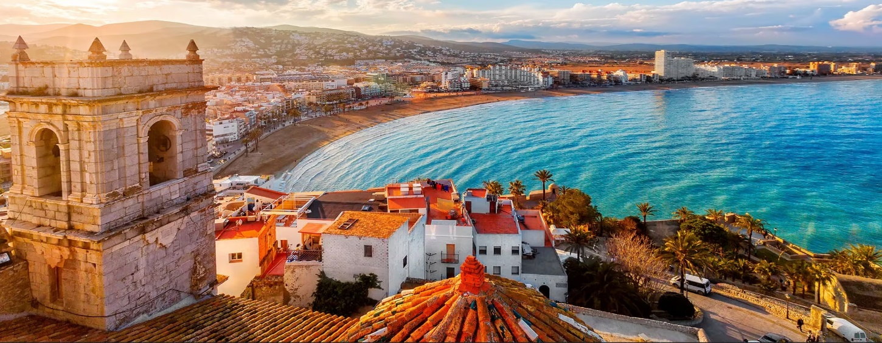
22-23 October 2024
Valencia, SPAIN
Inside the AINIA Conference Center – Includes Facility Tours
Registration & Sponsorship Form
NAME__________________________________________ E-Mail _________________________________________________
COMPANY _____________________________________________________________________________________________
ADDRESS_________________________________________________________Moble Phone__________________________
CITY____________________________________ STATE___________ POSTAL___________ COUNTRY ________________
Registration Per Person ____ 750 € Before 1st October – or 950 € after 1st October
____ 650 € for Additional Persons from Same Company (Before 1st October)
Registration Fee Includes: Classes + Lunch + Coffee Breaks + Cocktail Reception + Bus
Commercial Opportunities:
[ ] 750€ Tabletop Exhibit in Cocktail Reception [ ] 550€ full-page program book ad [ ] 950€ Bus Sponsorships
[ ] 3,000€ Lunch sponsor 22 Oct [ ] 2,500€ Cocktail Reception sponsor 22 Oct [ ] 750€ Daily Coffee Breaks
For Tabletops & Sponsorships, please Contact Terri Owens: terri@tortilla-info.com
PAYMENT Total = ________ BY: [ ] Credit Card (write below) [ ] Check (attached)
Cardholder _________________________________Card # ___________________________________________Exp______________
NOTE: For Wire Transfer Payment: Contact us for TIA’s Bank Details
Send: BY Postal Mail: TIA, 1400 North 14th Street, Arlington VA 22209, USA
BY E-Mail: Scan & Send To jkabbani@tortilla-info.com
NOTE: Currency conversion rate plus our bank fees set at € 0.92 Euros per $1.00 US Dollar .

